**Edge Impulse Lab Assignment**

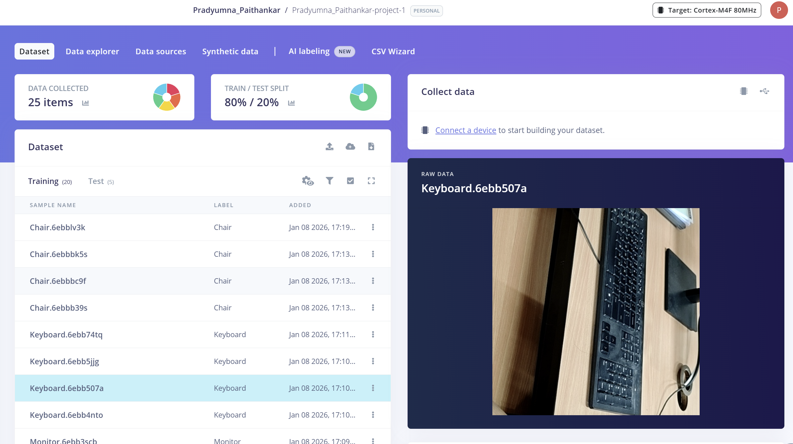

**Collected 30 items of 5 different classes and equally split them by 80/20.**

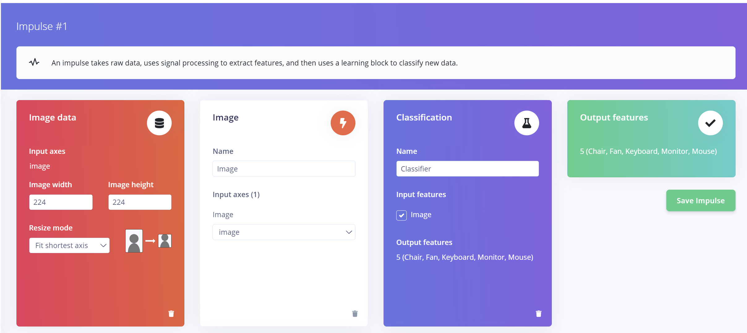

**Created a framework and kept the size of image data to be 224X224.**

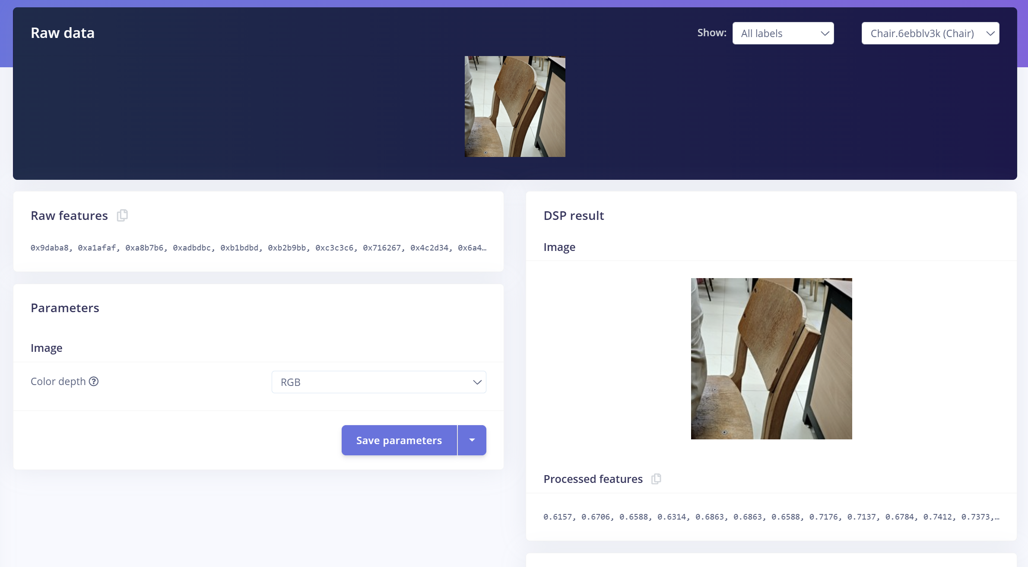

**Created features for each image as vector embeddings**

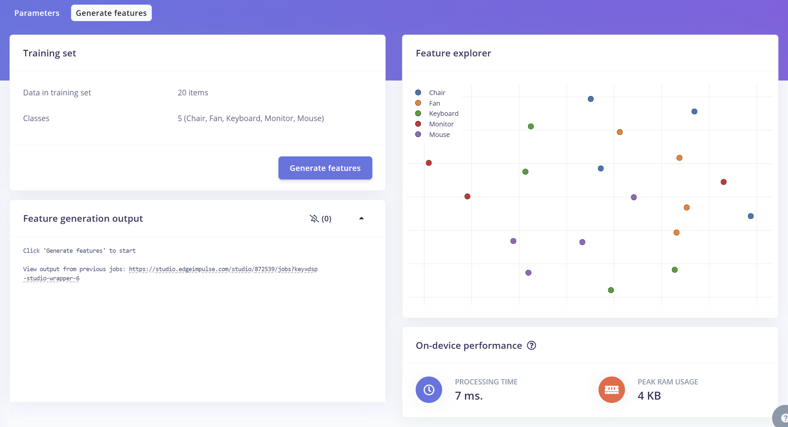

**Generated features from embeddings**

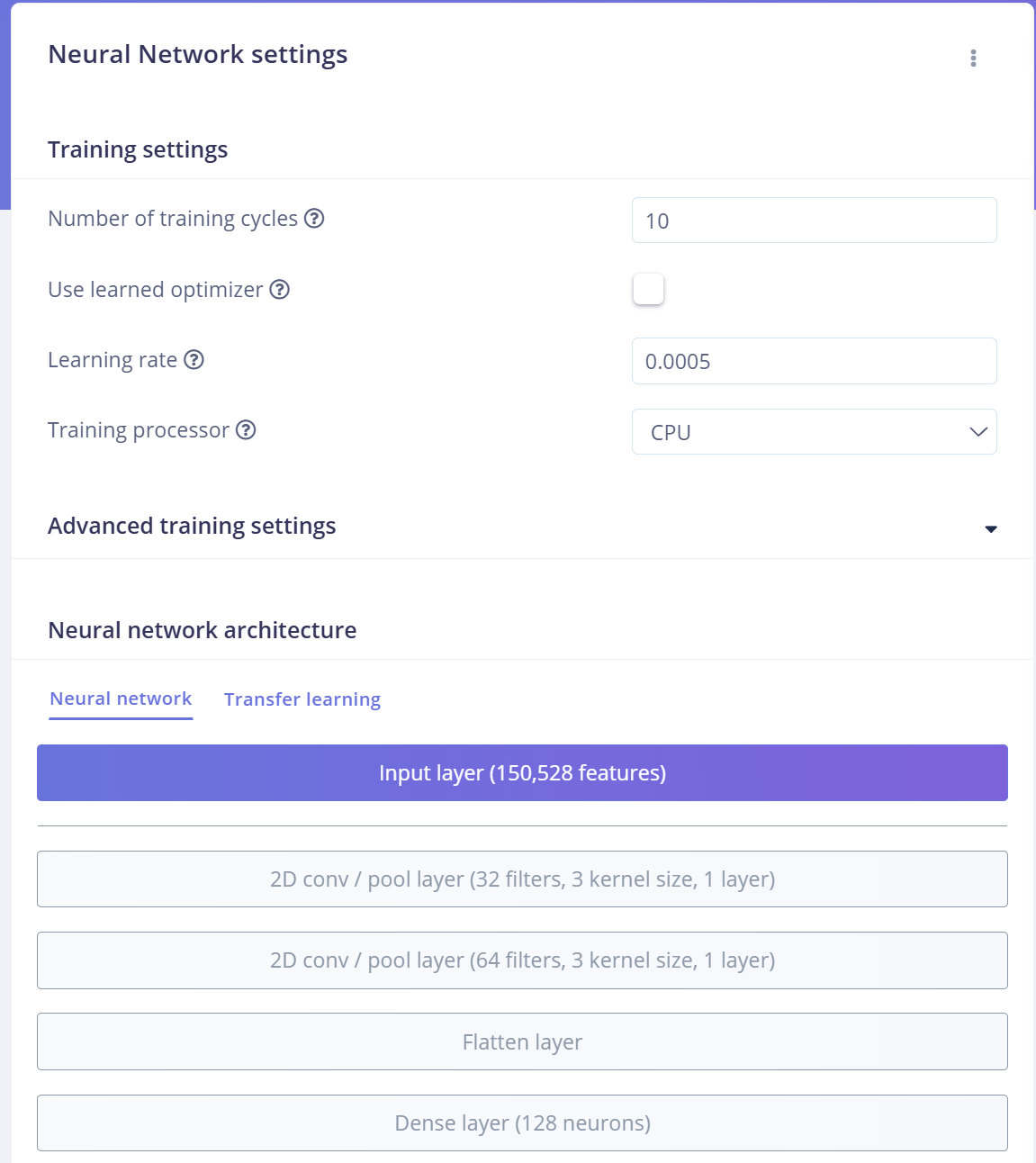

**Using default model with 10 epochs gave me 0% accuracy.**

**To boost that I did hyperparameter tuning by using 32, 64 size filters and 40 epochs with a dense layer at end with 128 neurons.**

**This improved my accuracy to 50% which was comparable to the transfer learning model (MobileNET).**

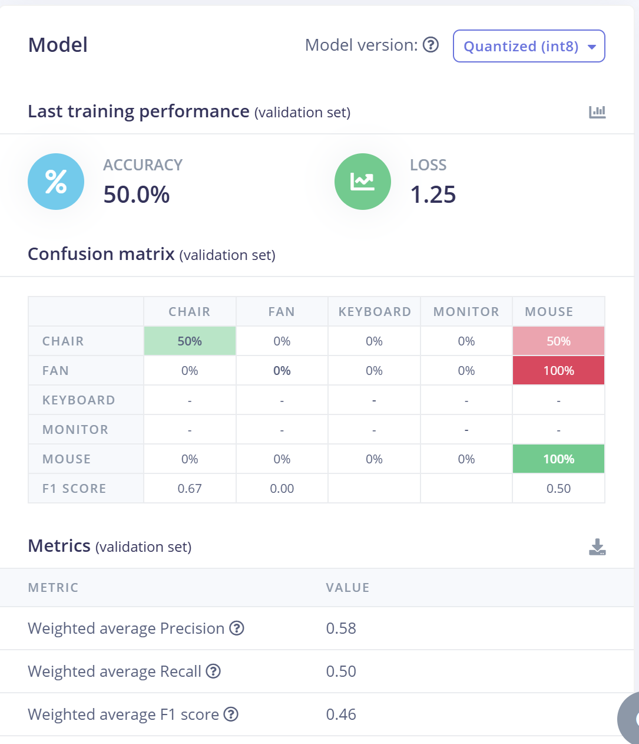

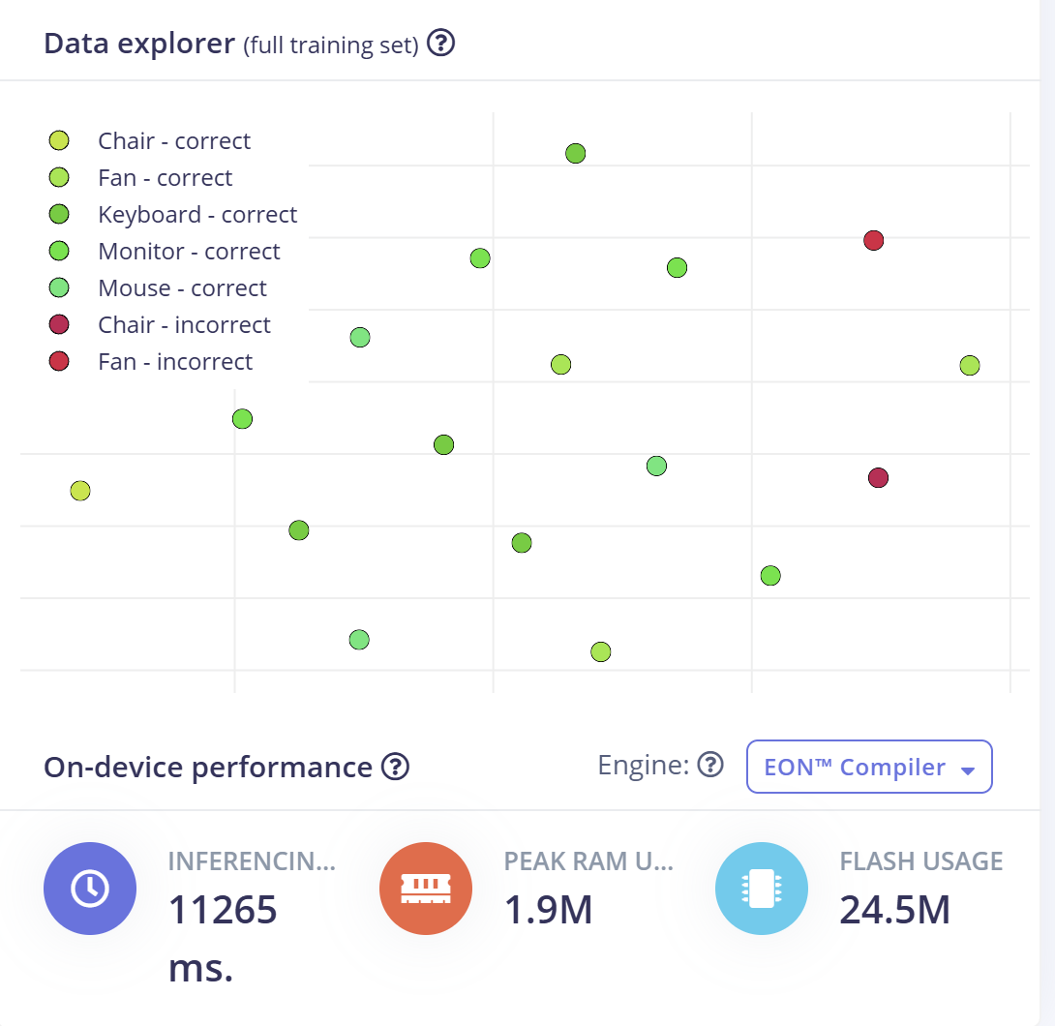

**I also tried using it for doing fruit classification on Kaggle fruit dataset.**

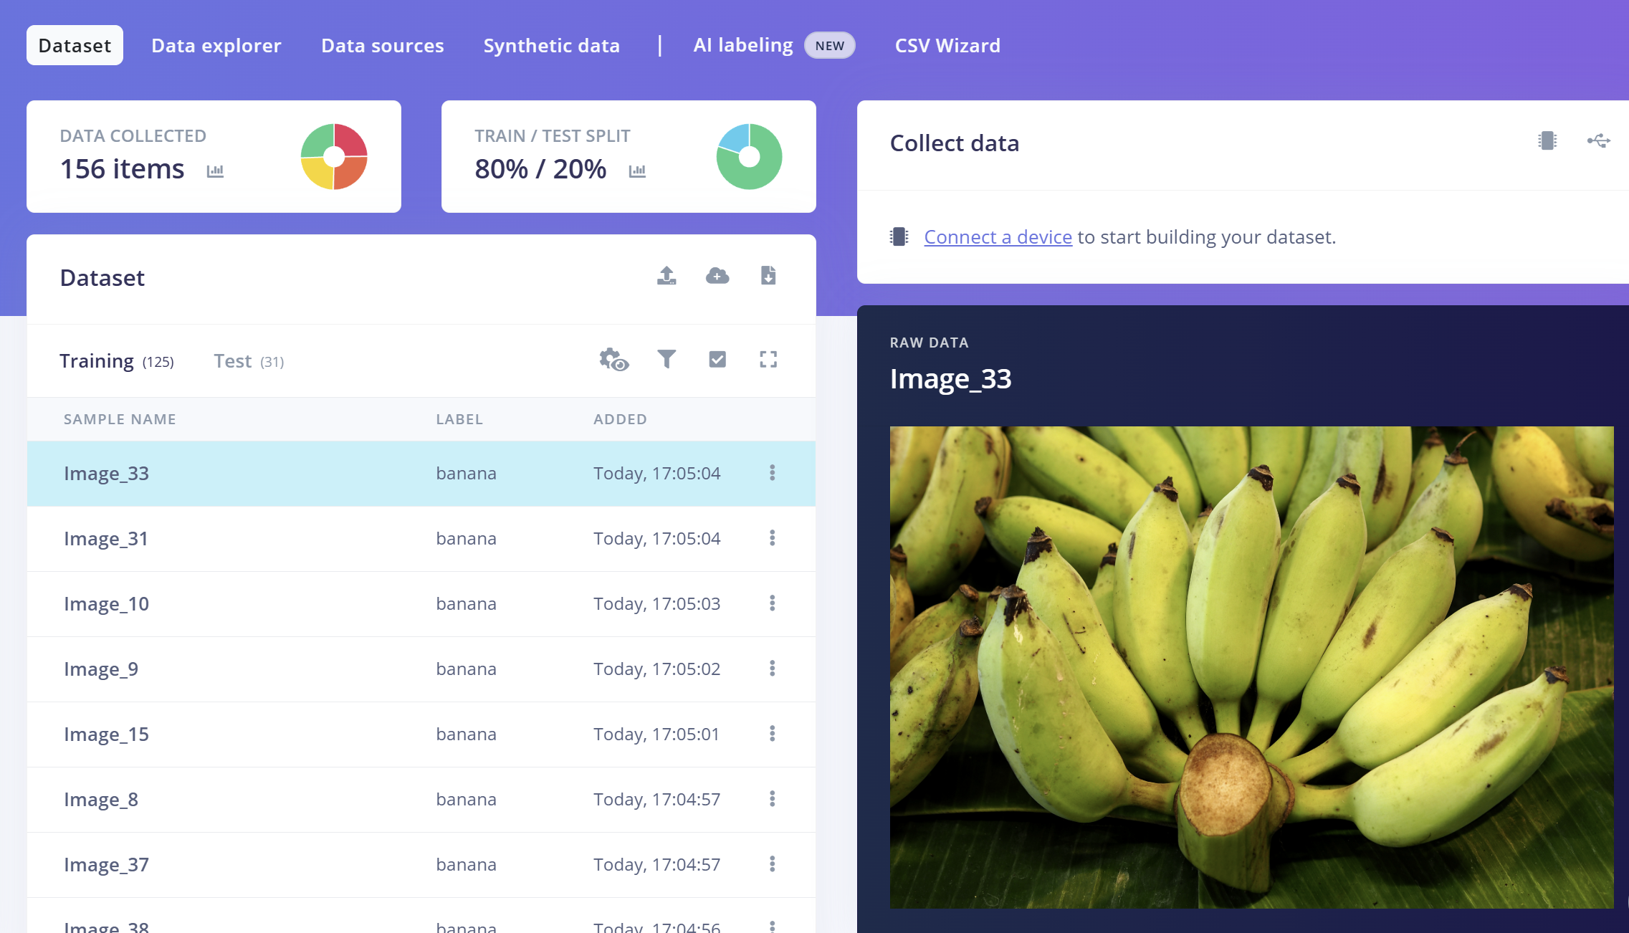

**Did the same process as previous one but just created RGB features instead of grayscale**

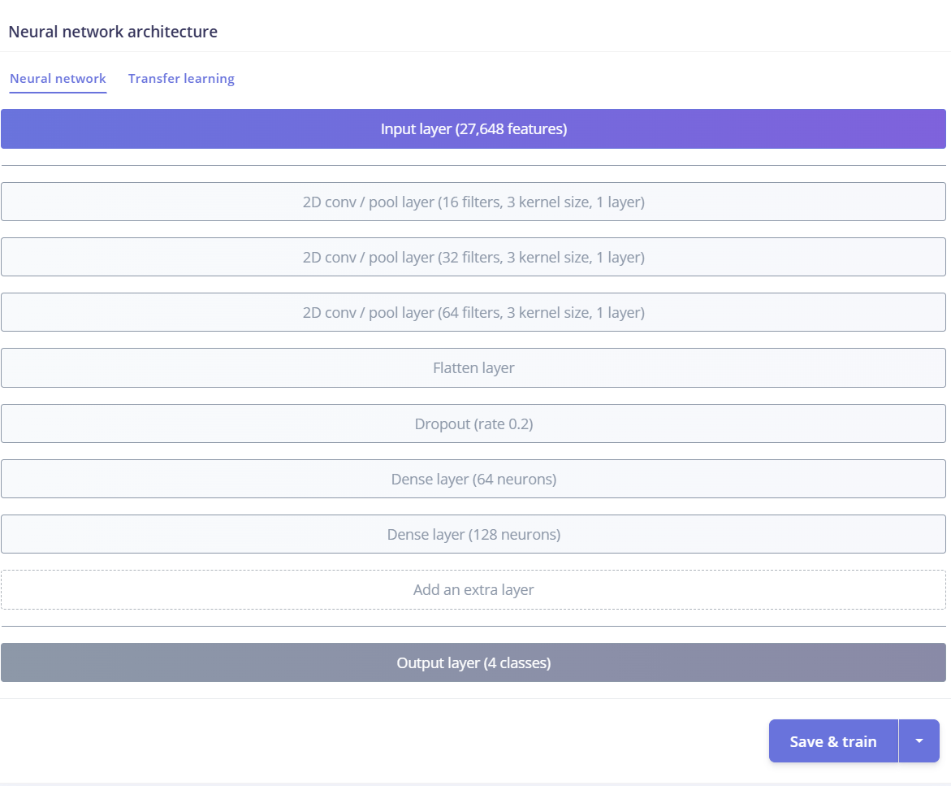

**As these images are more complicated, I used more layers in model.**

